Homework 2: Route Finding

Please keep the title of each section and delete examples. Note that please keep the questions listed in Part III.

Part I. Implementation (6%):

* 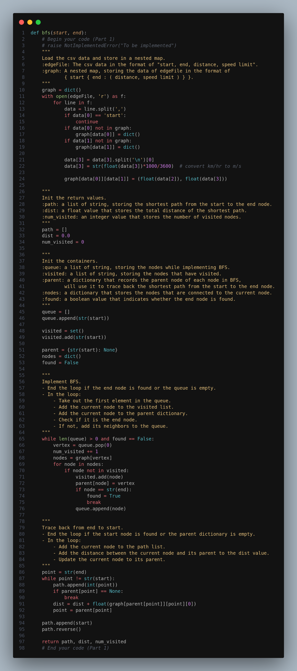Part 1: Breadth-first Search:



* 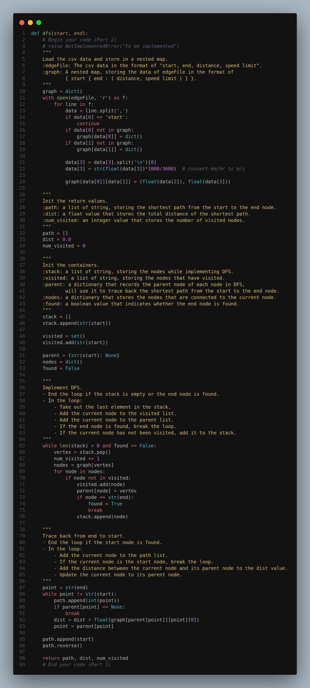Part 2: Depth-first Search(stack)



* 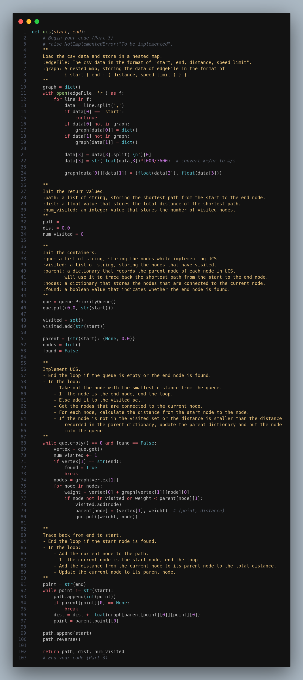Part 3: Uniform Cost Search



* 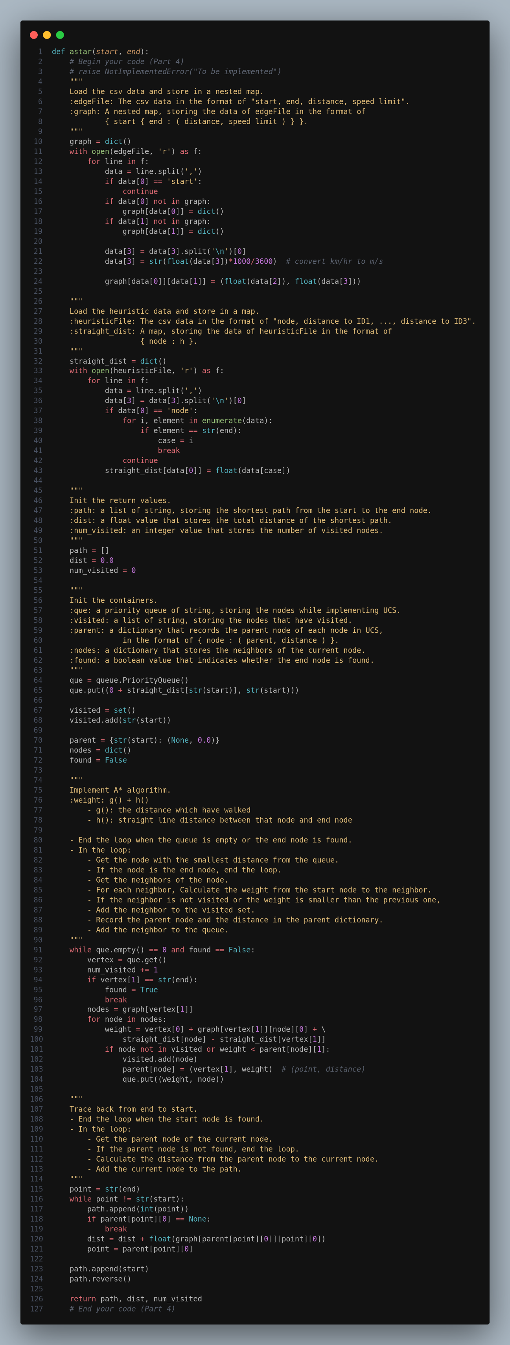Part 4: A* Search



* 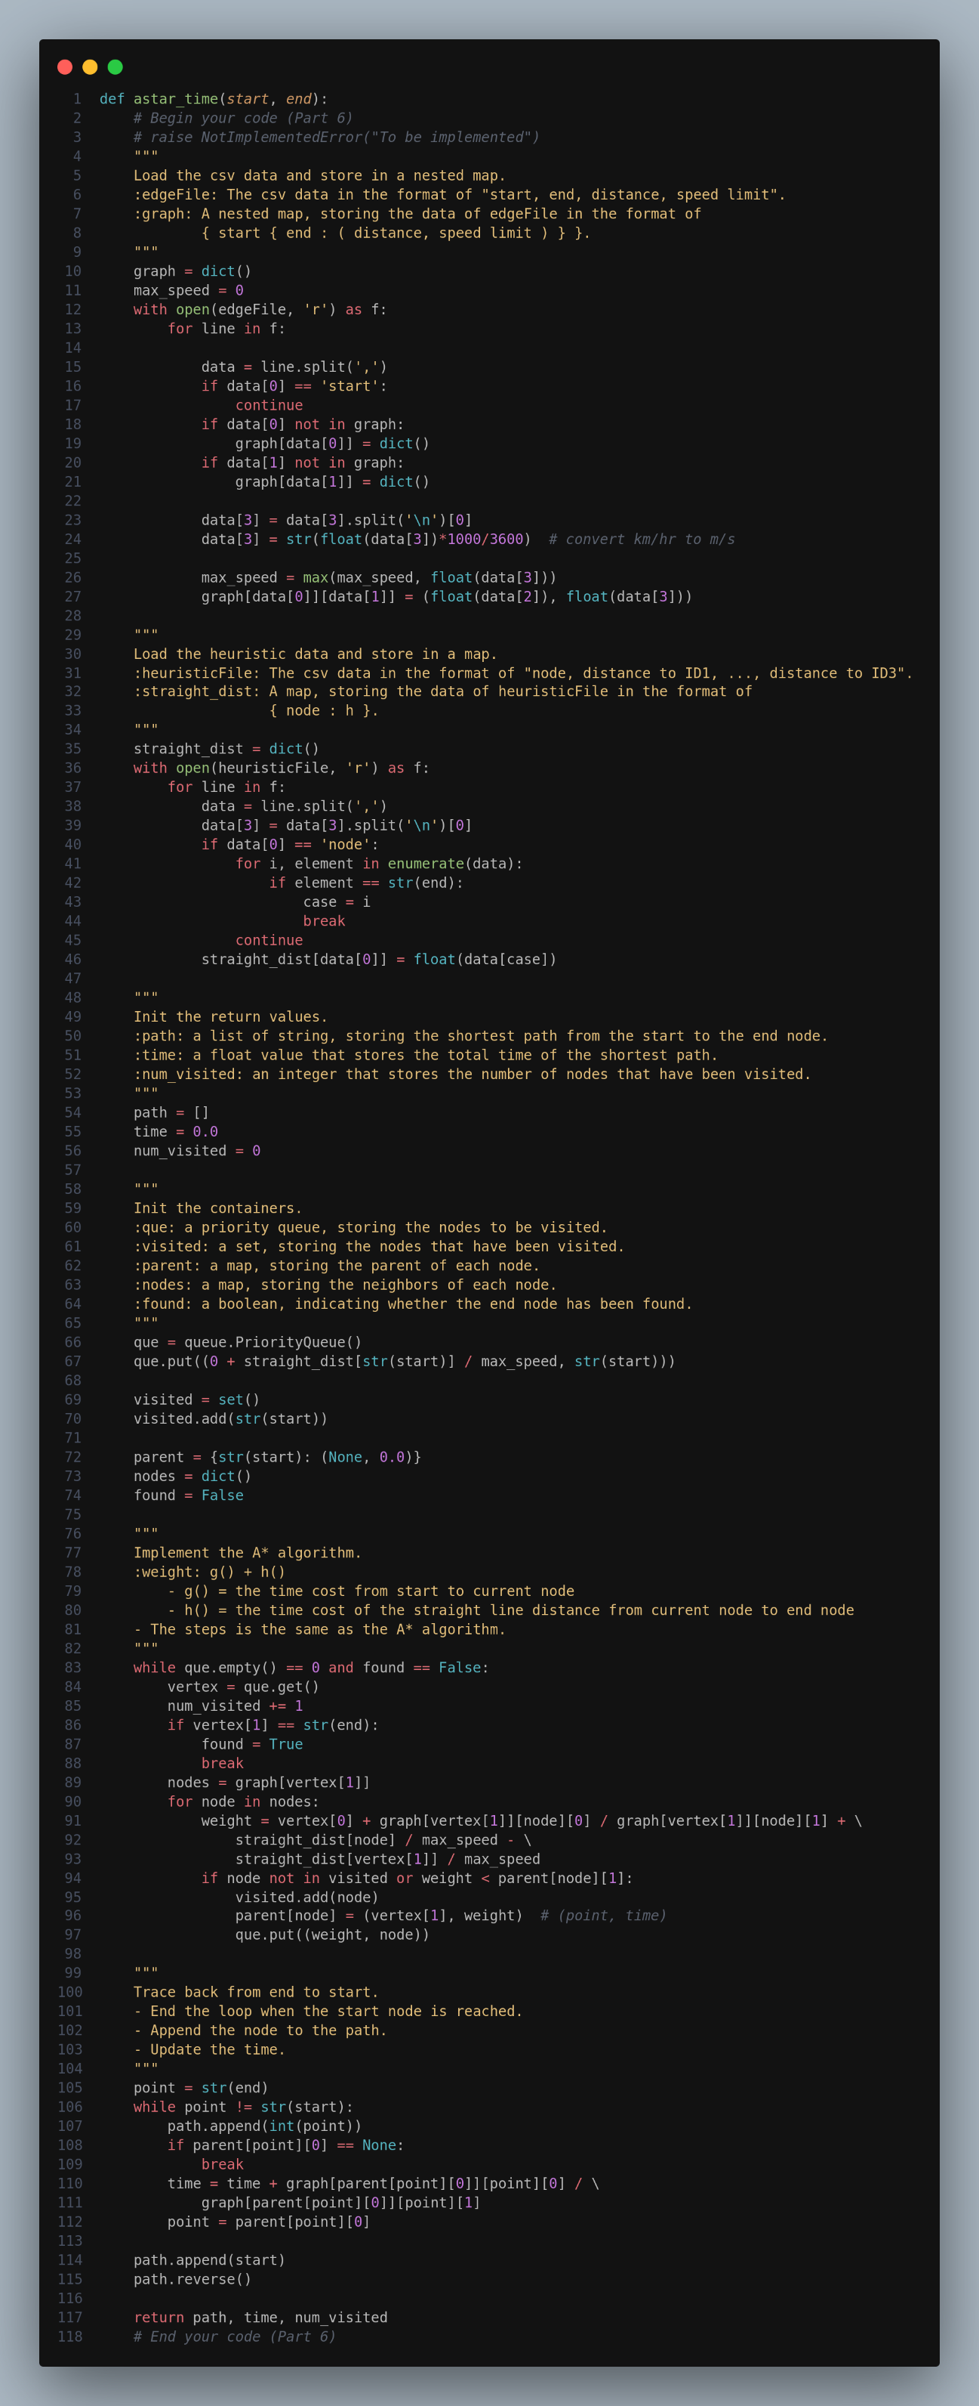Part 6: Search with a different heuristic (time)

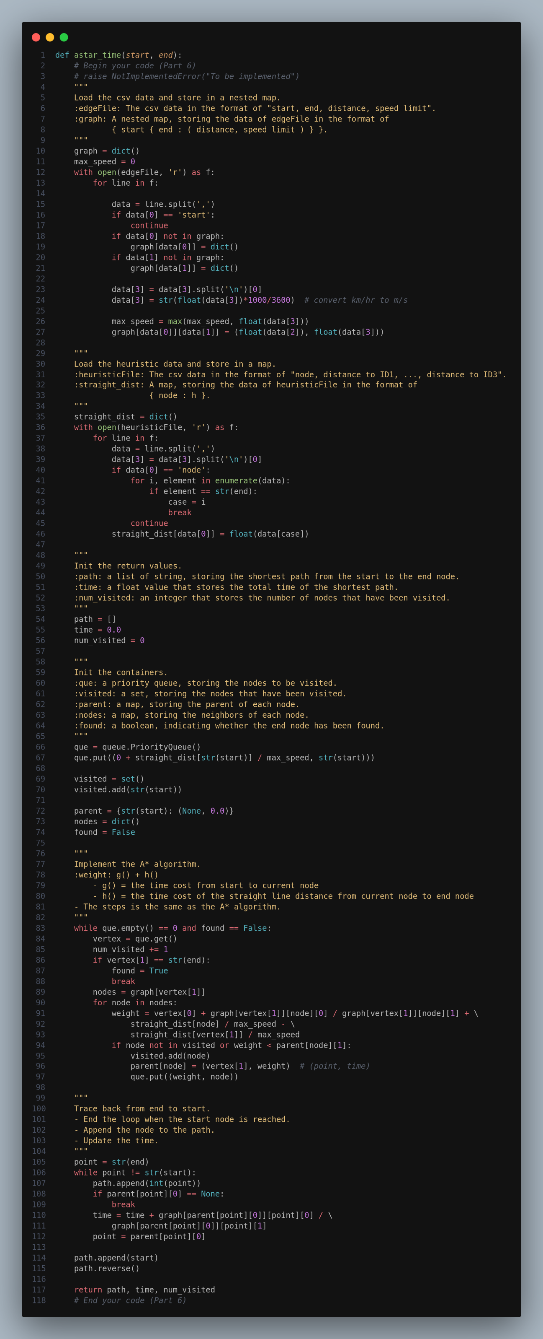

Part II. Results & Analysis (12%):

Please screenshot the results.

Test 1: from National Yang Ming Chiao Tung University (ID: 2270143902)to Big City Shopping Mall (ID: 1079387396)

* BFS

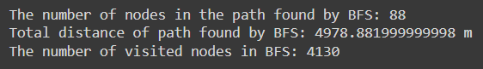

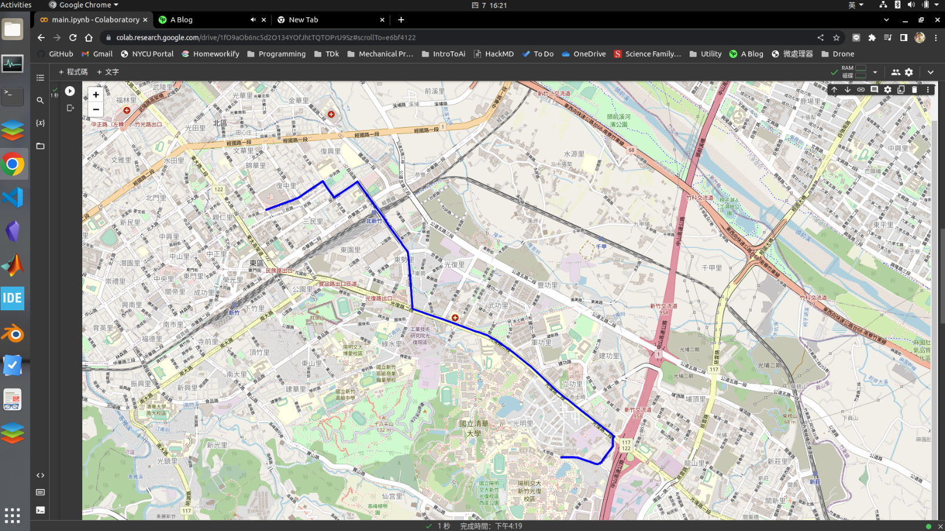

* 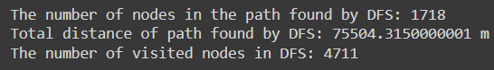DFS(stack)

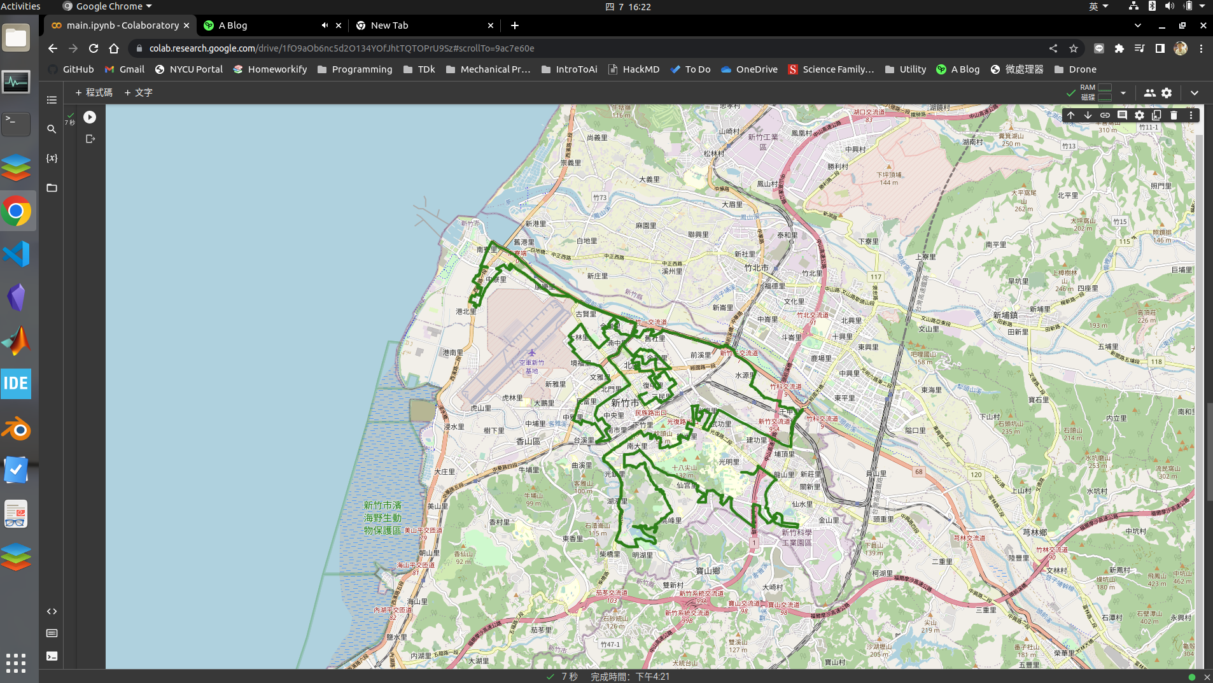

* 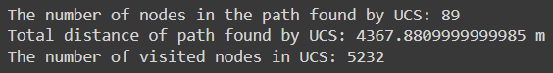UCS

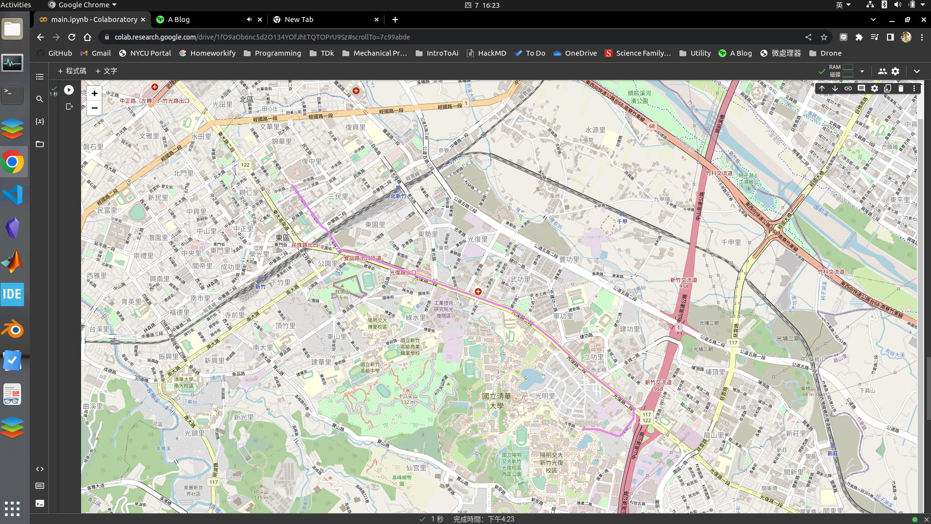

* A*

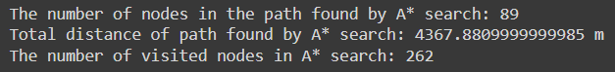

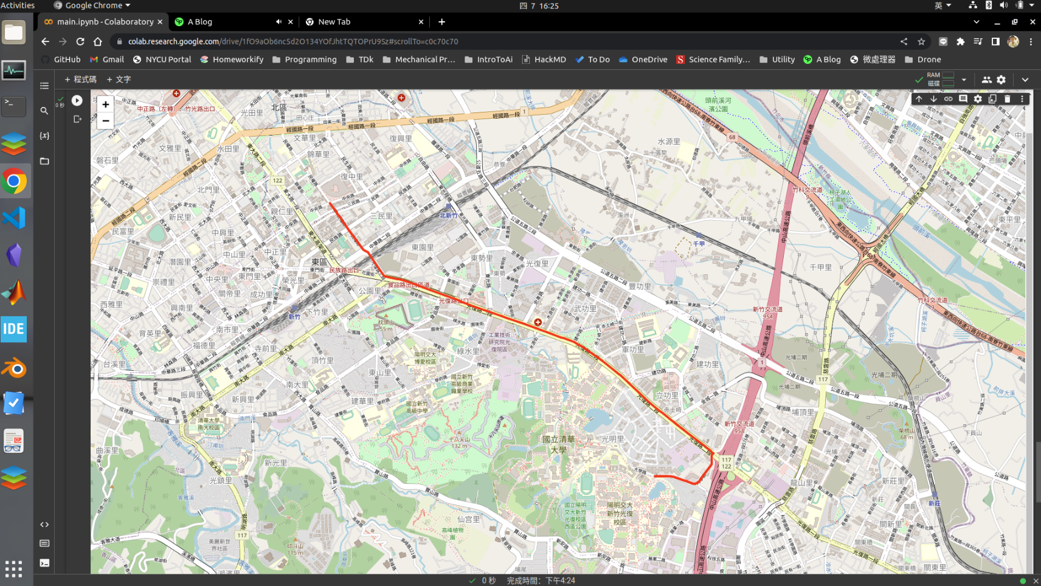

* A* (time)

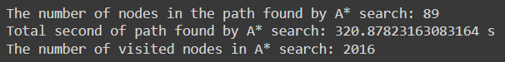

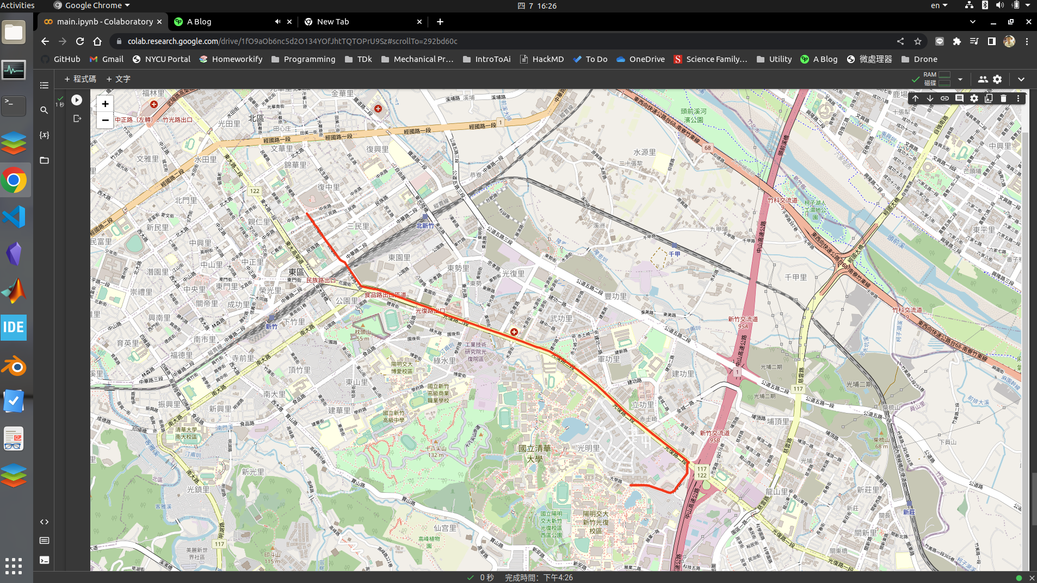

Test 2：from Hsinchu Zoo (ID: 426882161) to COSTCO Hsinchu Store (ID: 1737223506)

* BFS

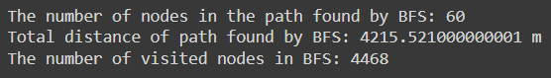

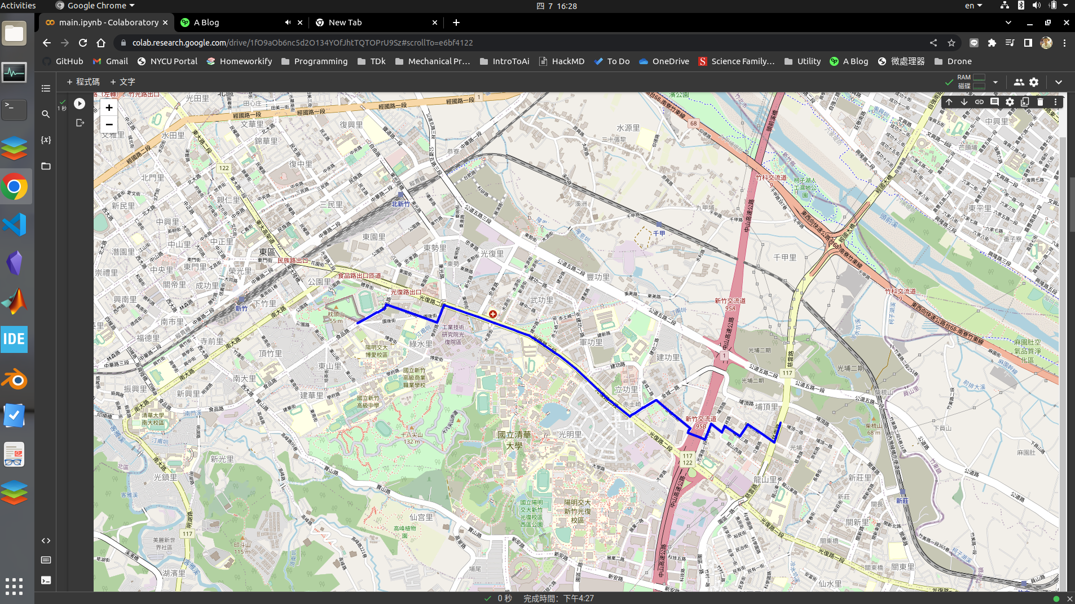

* DFS(stack)

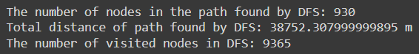

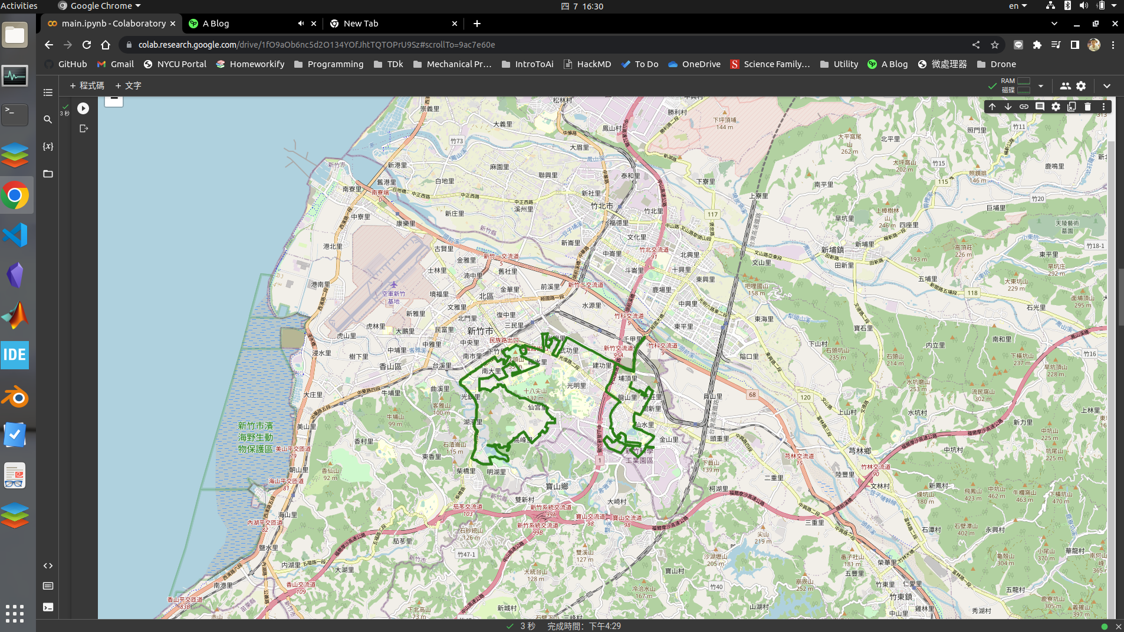

* UCS

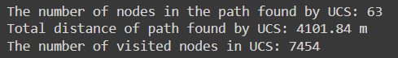

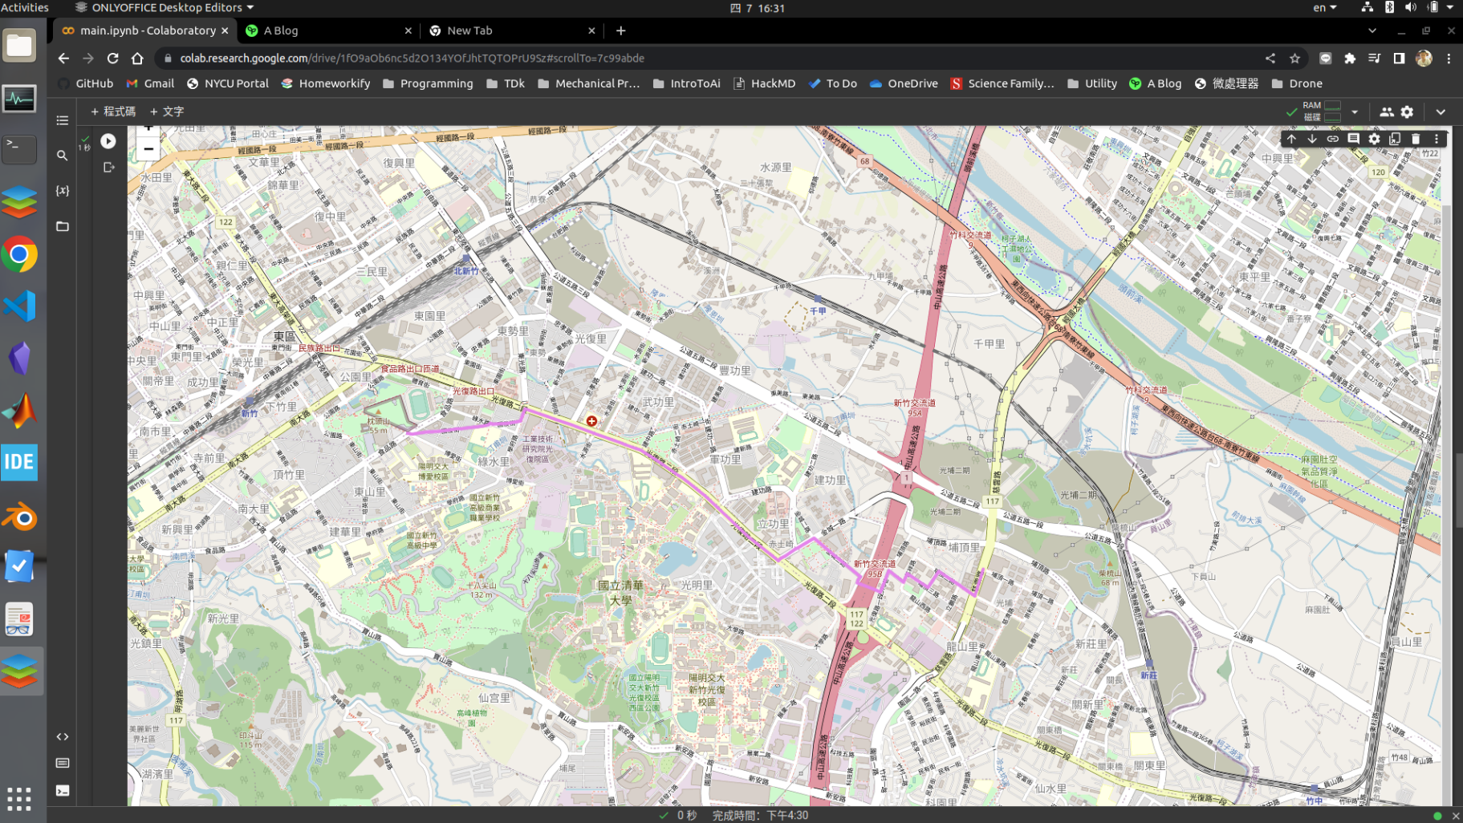

* A*

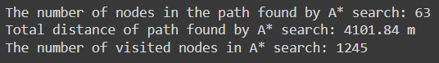

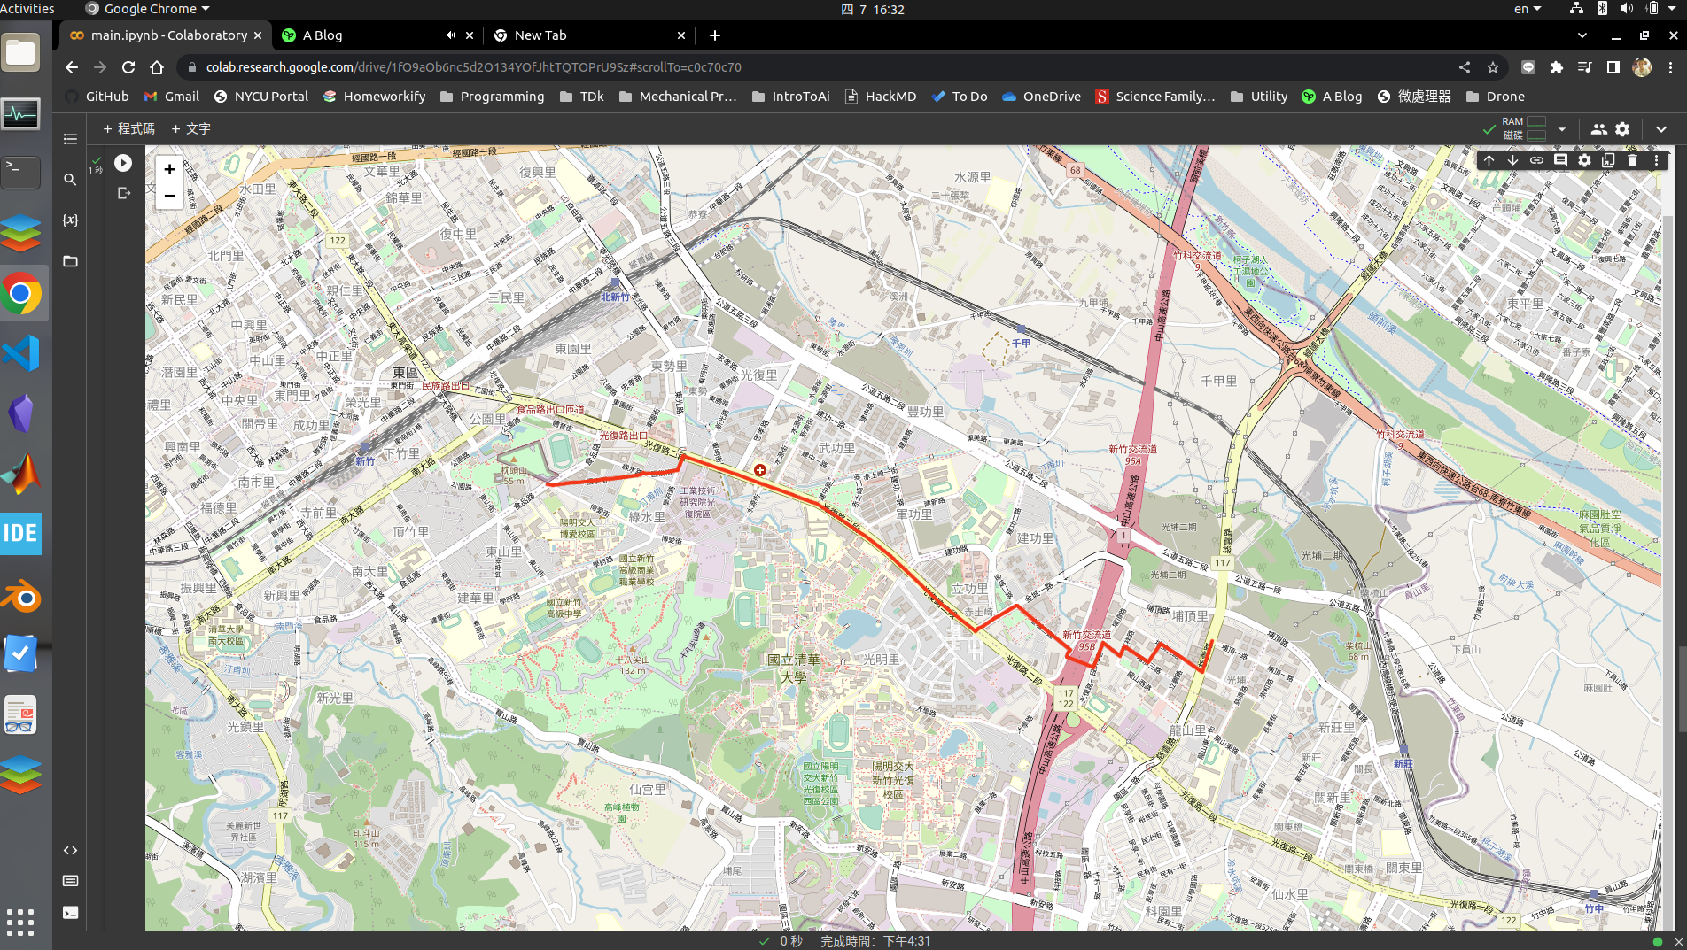

* 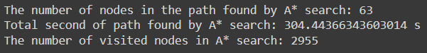A*(time)

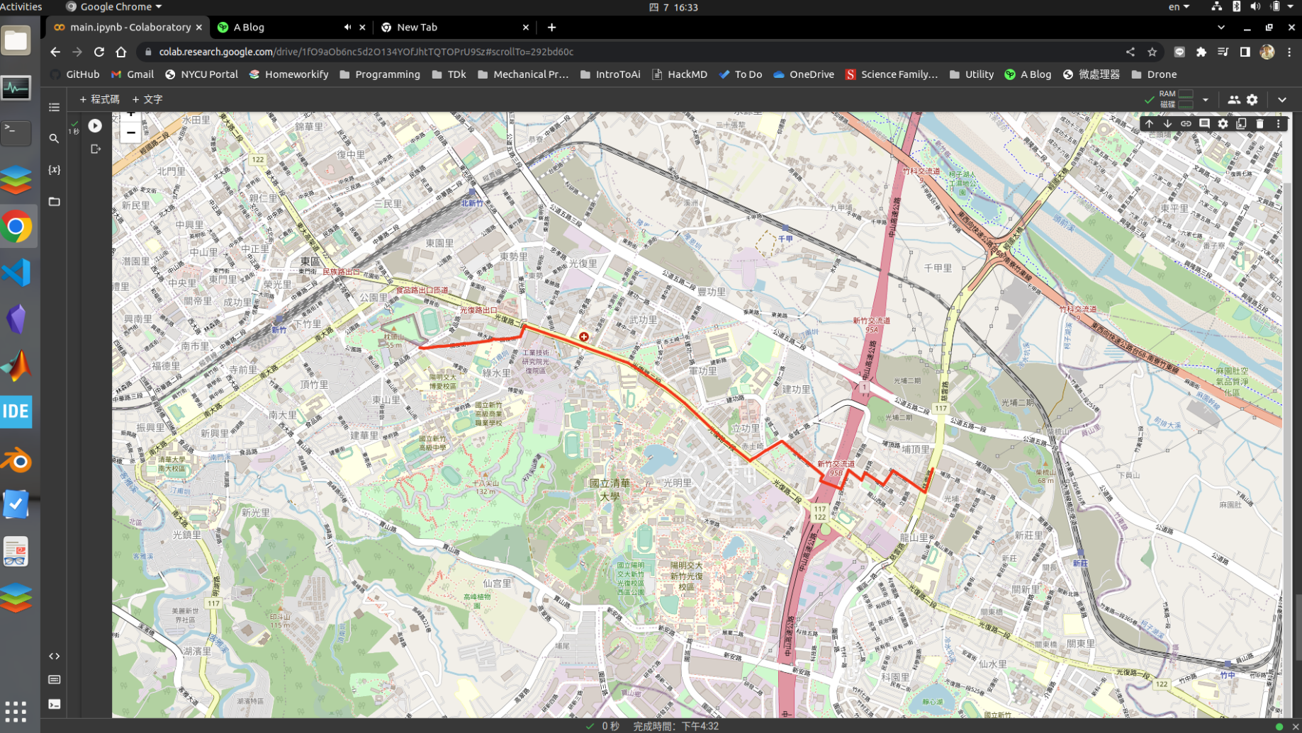

Test 3：from National Experimental High School At Hsinchu Science Park (ID: 1718165260) to Nanliao Fighing Port (ID: 8513026827)

* 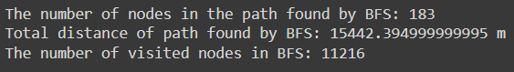BFS

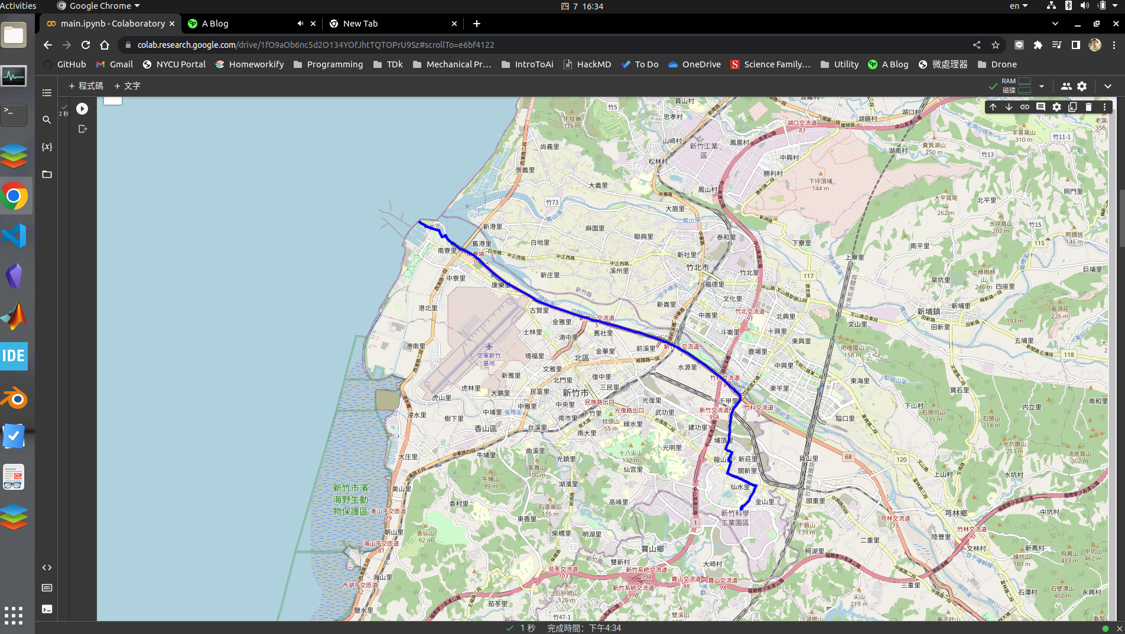

* 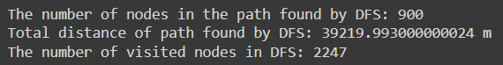DFS(stack)

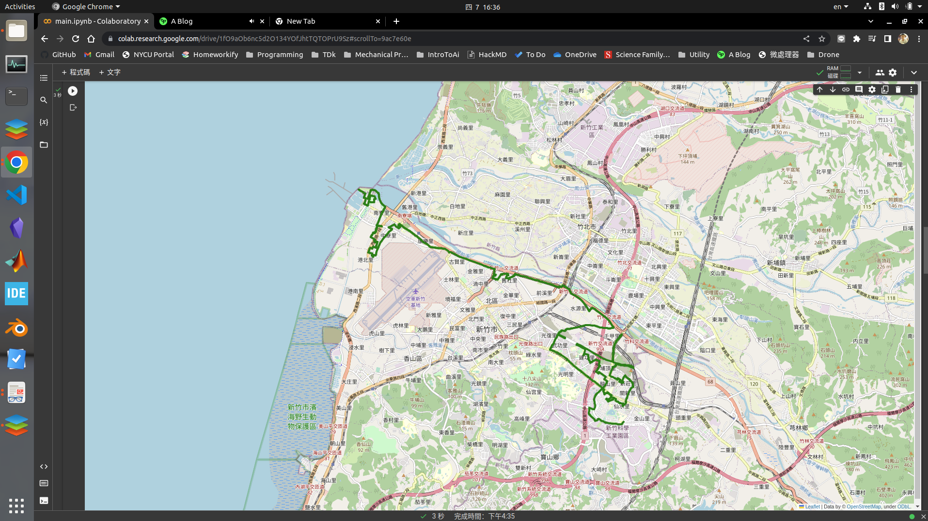

* 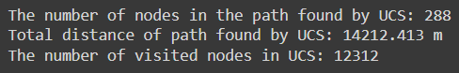UCS

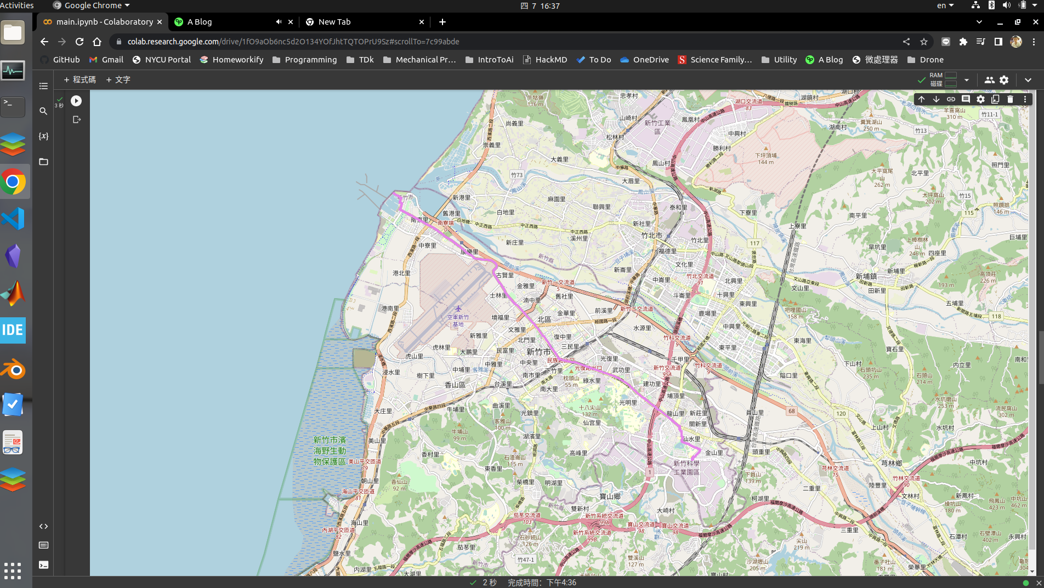

* 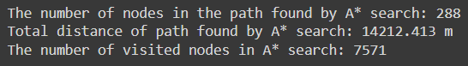A*

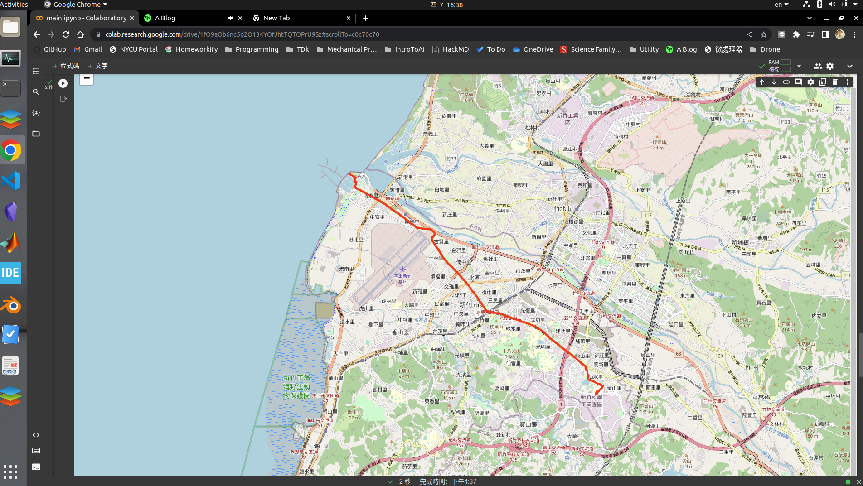

* A*(time)

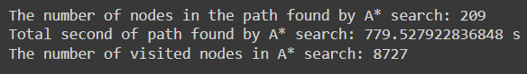

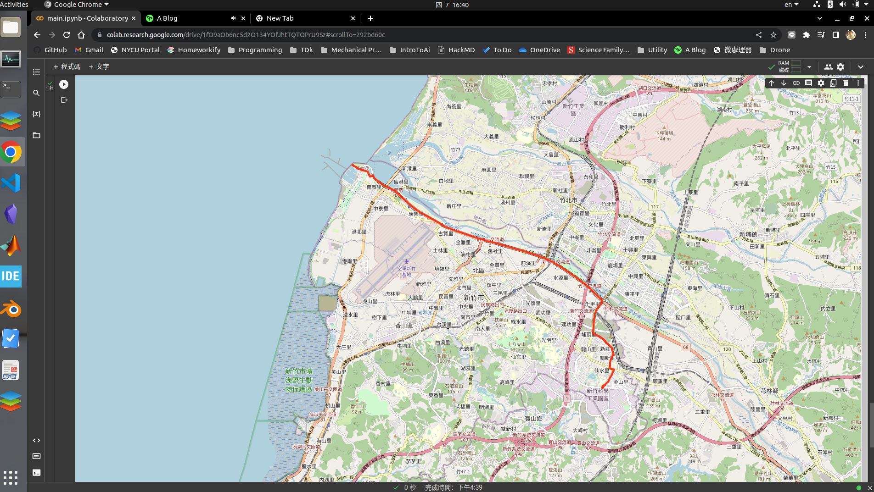

* Conclusion:

From the results, we found that UCS and A* are both two good ways in calculating the shortest path. If the target is far away from the start point, A* will be more effective than UCS, since UCS expands the search frontier uniformly in all directions, without any knowledge of the goal location, while A* using a heuristic function to estimate the distance between a node and the goal node.

For BFS, its performance is acceptable in comparison of DFS, though it is not an effect way, it is able to find the shortest way at least. For DFS, this algorithm does not take the distance between nodes into consideration, and it may miss the best solution while searching.

Part III. Question Answering (12%):

1. Please describe a problem you encountered and how you solved it.

A:

While loading the data from .csv file and storing it into a nest map, I made a mistake that use both the start node and end node as key to establish the dictionary.

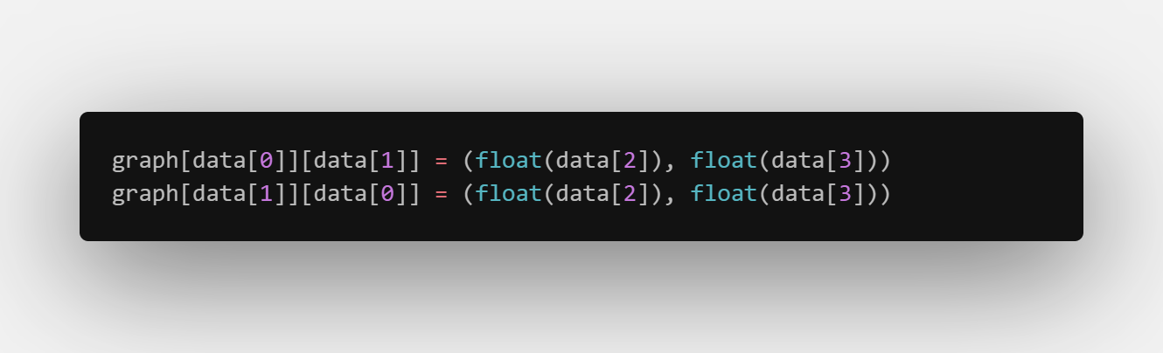

This would lead to the wrong result because it assumes that the shortest path between any two nodes is the same regardless of the direction of the path. However, in some cases, the shortest path between two nodes can be different depending on the direction of the path. I took few days to realize and fix it.

1. Besides speed limit and distance, could you please come up with another attribute that is essential for route finding in the real world? Please explain the rationale.

A:

The traffic condition like the amount of car will also affect the time we take to arrive the destination. During the rush hour, we might stock in the traffic jam, and to choose the longer path other than the shortest path might be able to arrive the destination earlier. Therefore, the road congestion is also essential for route finding.

1. As mentioned in the introduction, a navigation system involves mapping, localization, and route finding. Please suggest possible solutions for mapping and localization components.

A:

For localization, GPS is a widely used technology It uses a network of satellites to determine the location of a device on the Earth. It can be used for outdoor navigation but may not be accurate enough for indoor navigation.

For mapping, we can take the photos by street view car or satellites, then convert the image data to vector data, with which we can use in route finding.

1. The estimated time of arrival (ETA) is one of the features of Uber Eats. To provide accurate estimates for users, Uber Eats needs to dynamically update ETA based on their mechanism. Please define a dynamic heuristic equation for ETA and explain the rationale of your design. Hint: You can consider meal prep time, delivery priority, multiple orders, etc.

A:

Time_1 = meal prep time

Time_2 = for the delivery partner to reach the restaurant and picks up the meal

Time_3 = for the delivery partner to reach the delivery location

Time_4 = buffer for unexpected delays or traffic

ETA = Time_1 + Time_2 + Time_3 + Time_4